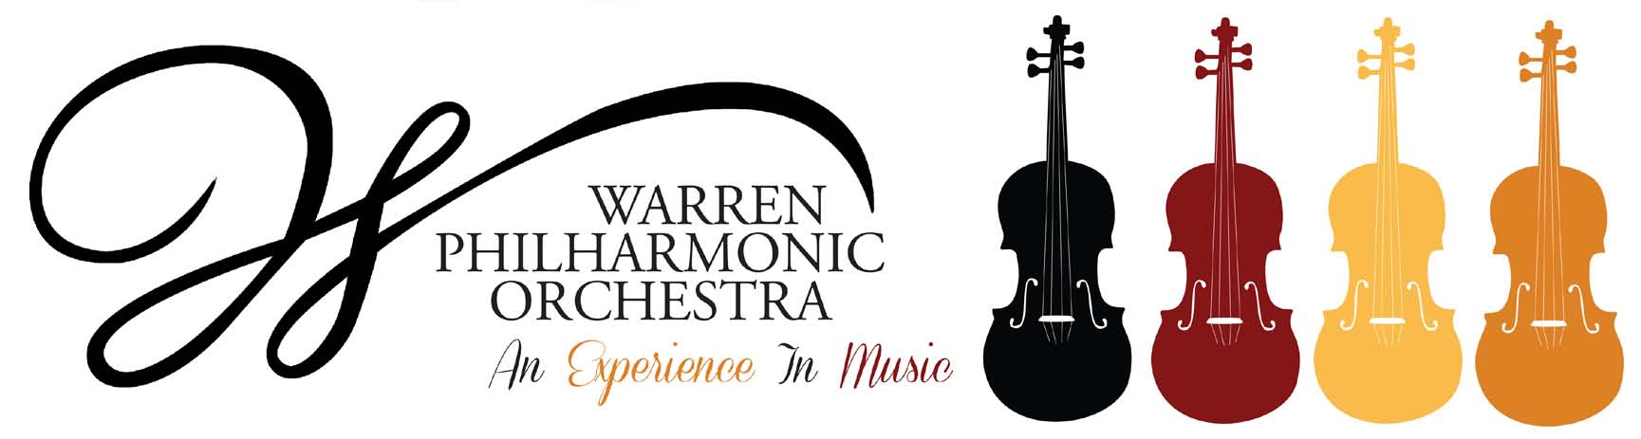P.O. Box 8507 Warren, OH 44484-8507

PRESS RELEASE FOR MORE INFORMATION:
FOR IMMEDIATE USE Leanna Dunaway
September 26, 2022 Phone: 330-399-3606 Email: warren.philharmonic@gmail.com

Luminous and Dancing Spirits!
October 23, 2022, WPO Concert Announced

​The entire community is encouraged to attend the Warren Philharmonic Orchestra’s fall concert featuring Luminous and Dancing Spirits! Witness a live orchestra composed of 50 of the area’s finest professional musicians in a venue with excellent acoustics. The program celebrates Patricia Lynn Latham – her artistry, her spirit and her indefatigable support of community arts and culture. The concert begins at 3 p.m. on October 23, 2022, at First Presbyterian Church, 256 Mahoning Avenue, NW, Downtown Warren, under the direction of the renowned conductor Susan Davenny Wyner.

The program features music by a gifted sister, rarely heard, and her famous brother, along with striking dances from different cultures. Included are an Overture by Fanny Mendelssohn Hensel, Greek Dances by Nikos Skalkottas, Starodávný Slavonic Dance by Antonín Dvořák, Hoedown by Aaron Copland, the Ritual Fire Dance by Manual De Falla and the Italian Symphony by Felix Mendelssohn.​

“What particularly excites me about this concert is the vibrant mix of styles and national characteristics along with the delicious surprise of hearing music by an extraordinary brother and sister who begin and end the program,” explains Davenny Wyner.

“Felix Mendelssohn’s music is well known, and his effervescent Italian symphony remains an irresistible favorite, but the music of his older sister Fanny is only now coming into its own. A brilliant pianist, she composed over 466 compositions. But in the 1800s – even with the support of her husband, court painter William Hensel, and her brother – women did not have public music careers, so her music was only performed in her famous salon concerts. Now to begin our concert, we get a chance to hear her brilliant and dramatic Overture for ourselves!

“In the center of the program, we feature contrasting dances: the strings show off quirky rhythms in Skalkottas’s Greek dances and the very American Hoedown from Copland’s Rodeo. The whole orchestra evokes mysterious Spanish spirits in de Falla’s Fire Dance, and in Dvorak’s Ukrainian Dumka, he contrasts soulful lilting melancholy with lively interwoven sections.”

Davenny Wyner concludes, “I think it is interesting to know that Brahms adored Dvorak's Slavonic Dances and gave the younger man not only his friendship but helped him get his music published. I feel we hear Brahms’s influence in the way Dvorak used the orchestra, particularly in this yearning and emotional Ukrainian dance.”

Tickets for the October concert can be purchased at the door; adults $30, students $15. Children under the age of 13 are admitted free, with parent or guardian. Advance reservations are not required. Season subscribers receive a ticket to each of our two concerts as well as one free ticket to bring a friend to either concert. And our flex plan allows the use of any ticket for either concert this season. Subscribers get three tickets for the price of two!

The Orchestra will follow CDC COVID-19 guidelines in effect at the concert’s date. For more information about the concerts or any of our youth outreach programs, contact the Philharmonic office at 330-399-3606 or email warren.philharmonic@gmail.com. Facebook: Warren Philharmonic Orchestra. Website: http://www.warrenphilharmonic.org/

# # #

