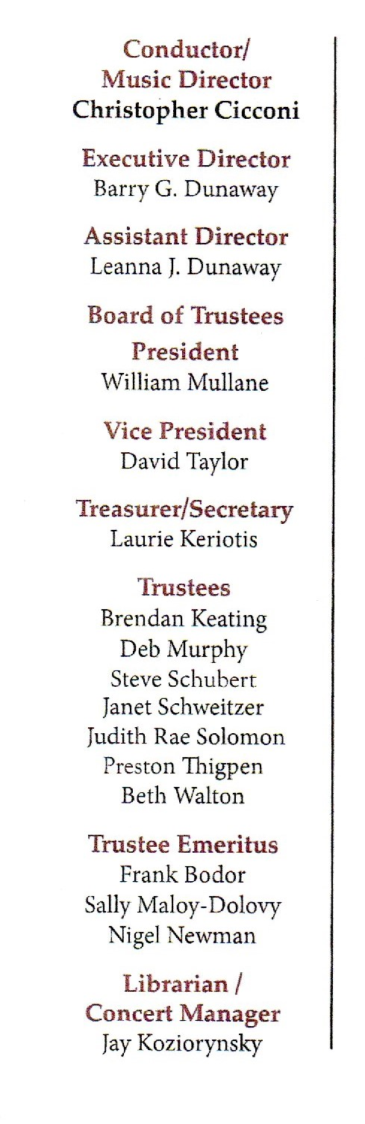

PRESS RELEASE FOR MORE INFORMATION
FOR IMMEDIATE USE Leanna Dunaway
Phone: 330-399-3606
Email: warren.philharmonic@gmail.com
Website: https://www.warren-philharmonic.org/

Songs and Dances
Warren Philharmonic Concert - Saturday, November 9th, 2024 at 7:00 PM
First Presbyterian Church, 256 Mahoning Avenue, NW, Warren 44483
The Warren Philharmonic Orchestra Fall 2024 Concert will begin at 7:00 PM at the First Presbyterian Church, 256 Mahoning Avenue, NW, in downtown Warren, OH. The concert date is November 9th, 2024.
The Warren G. Harding Symphonic Band will open the concert.
The Warren Philharmonic Orchestra will perform Overture to Die Fledermaus by Richard Strauss (1864 -1949), Pavane by Gabriel Fauré (1845-1924), Danzon No. 2 by Arturo Márquez (1950), and Symphony No. 8 by Antonin Dvorak (1841-1904). Program notes will be posted on the Warren Philharmonic Orchestra website.
The Warren Philharmonic’s 45-plus professional musicians with 50 different instruments have won raves for their superb performances, stellar musicianship and captivating programs of compositions from the 1700s to pieces just composed. The November Fall concert opens the Orchestra’s 59th performance season.

Tickets for the November 9th, 2024, concert can be purchased at the door: adults $30.00, students $15.00. Children under the age of 13 are admitted free, with a parent or guardian. Phone the Warren Philharmonic Orchestra office at 330-399-3606 or send email to warren.philharmonic@gmail.com for more information. Facebook: Warren Philharmonic Orchestra. Website: http://www.warren-philharmonic.org/

