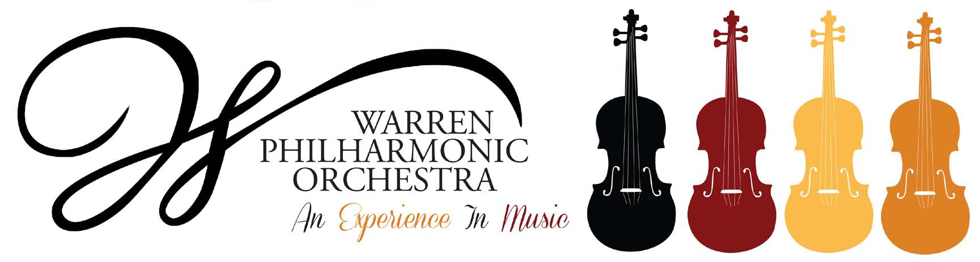P.O. Box 8507 Warren, OH 44484-8507

PRESS RELEASE FOR MORE INFORMATION:
FOR IMMEDIATE USE Leanna Dunaway
Phone: 330-399-3606 Email: warren.philharmonic@gmail.com

Spring Celebration!
Warren Philharmonic Concert - April 23, 2023

​The Warren Philharmonic Orchestra’s spring concert features a jubilant symphony by Beethoven, elegant music by Fauré, and vibrant pieces by two dynamic American women. The concert begins at 3 p.m. on April 23, 2023, at First Presbyterian Church, 256 Mahoning Avenue, NW, Downtown Warren.

Under the baton of music director and conductor Susan Davenny Wyner, the orchestra will perform ​Fanfare of Hope and Solidarity (2020) by Augusta Read Thomas, A Short Piece for Orchestra (1952) by Julia Perry, Pelléas et Mélisande Suite by Gabriel Fauré, and will conclude with the Eighth Symphony by Ludwig van Beethoven. Program notes are posted on the WPO website.

“Our Spring concert is full of excitement and contrasts,” explains Davenny Wyner. “We begin with a Fanfare. Augusta Read Thomas, born in 1964, is a galvanizing force among today’s composers. A Pulitzer Prize-winning finalist and Grammy Award winner, she is performed by major organizations all over the world. She sees and hears music in colors, often drawing colorful ‘maps’ of her compositions, and her short Fanfare was written to draw musicians together during the time of COVID-19. It is meant to be performed both virtually and live, and its instrumental ‘colors’ are bright and celebratory, a perfect way to call us together and open a concert.

“Next up is Julia Perry (1924-1979), an inspiring trailblazer who studied in Europe, won major fellowships, wrote music that both celebrated her African American roots and embraced the most current musical thought of her day. People may not know that she was raised very near here in Akron, Ohio. In 1965, the piece we are playing made history as the first work by a woman of color to be performed and recorded by the New York Philharmonic (and only the third work by a woman composer). Its music is powerful, dynamic, mysterious, and traverses a tremendous emotional landscape in its short span of time.”

Davenny Wyner continues, “After the energy and excitement of these American pieces, I wanted to bring us into a warm, sensual, emotional world. Fauré’s incidental music for Maeterlinck’s famous play Pélleas and Mélisande is loving and gentle, and the instrumental hues are subtle and mesmerizing, a complete contrast to the dynamism of our first two pieces on the program.

“We end our concert with Beethoven’s Eighth Symphony. What so excites me is that here we find an exuberant, uninhibitedly joyous Beethoven. The piece is filled with surprises, contrasts and humor. It is powerful, yes, and ideas are developed with intense and unrelenting vigor; but even when he does occasionally take us into dark or mysterious worlds, he releases us into joy,” she concludes.

The Orchestra’s 40-plus professional musicians with 50 different instruments have won raves for their superb performances, stellar musicianship and captivating programs of compositions from the 1700s to pieces just composed. The April concert concludes the Orchestra’s 57th performance season.

Tickets for the April concert can be purchased at the door; adults $30, students $15. Children under the age of 13 are admitted free, with parent or guardian. For more information about the concert or any of our youth outreach programs, contact the Philharmonic office at 330-399-3606 or email warren.philharmonic@gmail.com. Facebook: Warren Philharmonic Orchestra. Website: http://www.warrenphilharmonic.org/

###

