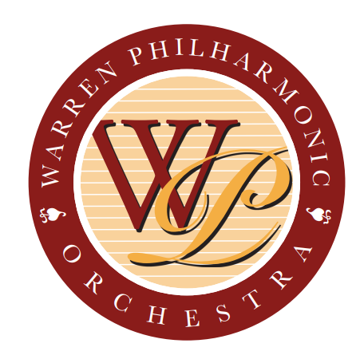

154 North Park Avenue, Warren, OH 44481

PRESS RELEASE FOR MORE INFORMATION:
FOR IMMEDIATE USE Leanna Dunaway, Assistant Executive Director
Phone: 330-399-3606
Email: warren.philharmonic@gmail.com

WPO Opens Applications for Free Violin Lessons to Next Class of Students

The Warren Philharmonic Orchestra is offering free violin lessons to a select group of Trumbull County third through seventh grade students, announced Barry G. Dunaway, executive director of the Orchestra. The application deadline is September 30, 2024, for the next class of students beginning October 6, 2024, and ending May 2025. An application form and related documents are available to download from the WPO website at https://www.warren-philharmonic.org/strings-of-joy
or can be requested from the WPO office, 154 North Park Avenue in Downtown Warren.

“The Frank R. Bodor Strings of Joy program continues the Orchestra’s outreach to area schoolchildren,” explained Dunaway. “The orchestra will perform a live concert for area students in October and encourages them to attend our public concerts in October and April. We appreciate the Youngstown/Warren Regional Chamber Foundation, other community organizations and individual donations that make the Frank R. Bodor Strings of Joy program possible at no cost to the students,” Dunaway said. “A limited number of students can be accepted,” he stressed. This will be the tenth Strings of Joy class receiving instruction since January 2016.

“The current Warren Philharmonic Orchestra board has recognized our former board president by renaming the Frank R. Bodor Strings of Joy program in the late Attorney Bodor’s honor. Frank was the first to suggest that we put violins into the hands of young students, and the Orchestra family is pleased to honor Frank in this way” Dunaway explained.

The Orchestra will loan each Strings of Joy student an age-appropriate violin and provide individual, 30-minute lessons Sunday afternoons through May 2025. Occasional group lessons and performance opportunities will be scheduled, as well. The Orchestra will provide printed music to the students at no cost. The lessons will be held at Christ Episcopal Church, 2627 Atlantic Street, NE, Warren, OH 44483.

Lesson instructor is Jenna Barvitski, a graduate of Youngstown State University’s Dana School of Music, where she was honored as a Leslie H. Cochran Academic Scholar. Barvitski is an experienced music educator for grades K-12, having taught at Lordstown Local Schools. She has provided private lessons and has directed choirs and orchestras.

“With string programs eliminated from most area schools, the Frank R. Bodor Strings of Joy program helps fill a need for those students interested in learning to play the violin and develop a deeper appreciation for our musical heritage,” Dunaway explained.

Parents/Guardians must be willing to provide transportation for the lessons, provide encouragement and practice space, and assume ultimate responsibility for the instrument. The Enrollment Agreement can be downloaded from the WPO website https://www.warren-philharmonic.org/strings-of-joy .

Parents/Guardians needing more information about Strings of Joy can contact Dunaway at 330-399-3606 or warren.philharmonic@gmail.com.

Website: https://www.warren-philharmonic.org/
Facebook: Warren Philharmonic Orchestra

###

