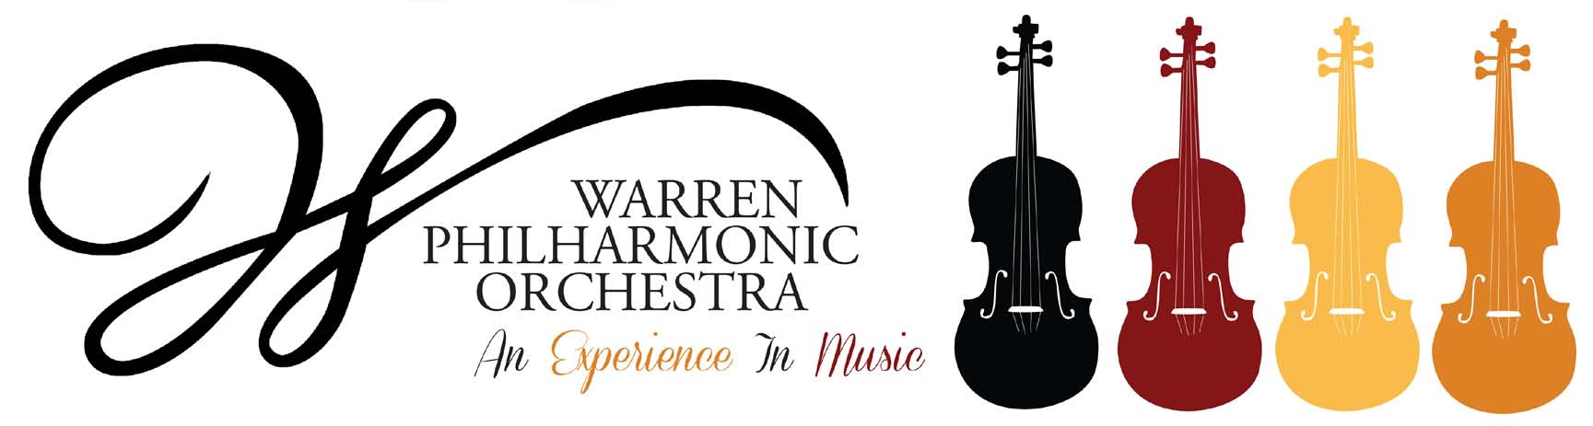P.O. Box 8507 Warren, OH 44484-8507

PRESS RELEASE FOR MORE INFORMATION:
FOR IMMEDIATE USE Leanna Dunaway
March 11, 2019 Phone: 330-399-3606 Email: warren.philharmonic@gmail.com

A Spring Bouquet! – Next WPO Concert Welcomes Spring
New Location Announced

The Warren Philharmonic Orchestra’s spring concert – A Spring Bouquet! – will help put music lovers in the mood for spring, with exotic tales, a charismatic star and the lure of dance. The concert begins at 3 p.m. on April 7, 2019, at First Presbyterian Church, 256 Mahoning Avenue, NW, Downtown Warren. Regular attendees should note the new location.

The orchestra will perform Scheherazade, Tales of Arabian Nights by Nikolai Rimsky-Korsakov, with soloist Joseph Kromholz, violin. Karen Clark-Green, soprano, actress and TV star, will contribute a bouquet of songs, including Broadway hits from Bridges of Madison County, Stephen Sondheim and pieces by Ricky Ian Gordon. Also, the orchestra will perform In the Mood by Glenn Miller and West Side Story selections for orchestra by Leonard Bernstein, in celebration of the centenary of Bernstein’s birth.

Prize-winning Art in Music Contest winners will be recognized, and their art works will be displayed in Fellowship Hall. In its 11th year, the contest is open to Trumbull County students in grades 3 through 8. Each student is asked to create a work on paper about the orchestra's instruments and the music to be performed at this year's Spring Concert. Artwork should express the entrant's feelings and his/her visual interpretation of the music and the concert experience. Teachers are provided CD recordings of selections from the concert, along with notes from WPO conductor Susan Davenny Wyner that introduce the music. All contest materials and rules are available at http://www.warrenphilharmonic.org/art-in-music-contest-2019.html.

Karen Clark-Green, originally from Warren, Ohio has been performing professionally since the age of 9. She is an original member of the Kenley Players starting in the 1959 production of the King and I with Betty White, in which she was one of the King’s children. She has performed the opera Porgy and Bess over 37 times as Bess, Serena and Clara. Other Opera credits include Madame Butterfly, Cosi fan Tutte, Turandot, Rigoletto, Aida, La Boheme, The Medium, The Magic Flute, The Crucible, The Old Maid and the Thief, Carmen, Susanna and the PBS performances of Hansel &Gretel and Albert Herring.

Ms. Clark-Green has earned degrees from Youngstown State University and The University of Akron. In 2018, she choreographed and co-directed along with David Vosburgh the opera Porgy and Bess for Opera Western Reserve’s production -- in collaboration with The Warren Philharmonic. Presently she can be seen as Grandma Lucille in the Amazon Prime TV series Mafia Ties, as she continues her musical theater career.

Joseph Kromholz is head of strings at Youngstown State University’s Dana School of Music, where he teaches violin, viola and chamber music. He is concertmaster for the Warren Philharmonic, as well as for Opera Western Reserve, and Associate Concertmaster of the Youngstown Symphony and CityMusic Cleveland Chamber Orchestra.

Susan Davenny Wyner, WPO Music Director and Conductor, says, “This is such a thrilling concert! It takes us from the rich exoticism of Scheherazade to down-home American styles – all woven together by the magic of musical story tellers. I am particularly excited about the range and contrast of the music, our eloquent soloists, and our new venue. Warren's historic First Presbyterian Church with its warm sound brings the audience right up close to the orchestra's musicians!

“Our program begins with Scheherazade,” Davenny Wyner continued, “who had to spin tales for 1001 nights to save her life. Rimsky-Korsakov gives her voice to the solo violin, while the orchestra takes us through a shipwreck, a tumultuous festival of dancers and warriors in Baghdad, gorgeous love music, and extraordinary depictions of the sea. Many people don't know that our composer was in the Navy for years, sailed the world, wrote music aboard ship, and became fascinated by faraway cultures.

“We move to America for our second half. Karen Clark-Green sings settings of Langston Hughes and Emily Dickinson poems plus award winning songs from Sondheim and Jason Robert Brown. Bernstein's West Side Story Selections for Orchestra gives Shakespeare's Romeo and Juliet an American twist. And for a grand finale the orchestra sends us out with In the Mood by our king of swing Glenn Miller.

“I think and hope the audience will be as fascinated as I am by how differently great composers tell stories and weave spells through music. How they captivate us by the way they use the instruments, rhythms, melodic contours, harmony, length and breadth of phrases. How they capture faraway places, and in American music, how much of it is built on rhythms we know from our own popular culture."

Tickets for the April concert can be purchased at the door; adults $25, students $15. Children under the age of 13 are admitted free, with parent or guardian. For more information about the concerts or any of our youth outreach programs, contact the Philharmonic office at 330-399-3606 or email warren.philharmonic@gmail.com. Facebook: Warren Philharmonic Orchestra. Website: http://www.warrenphilharmonic.org/

# # #

