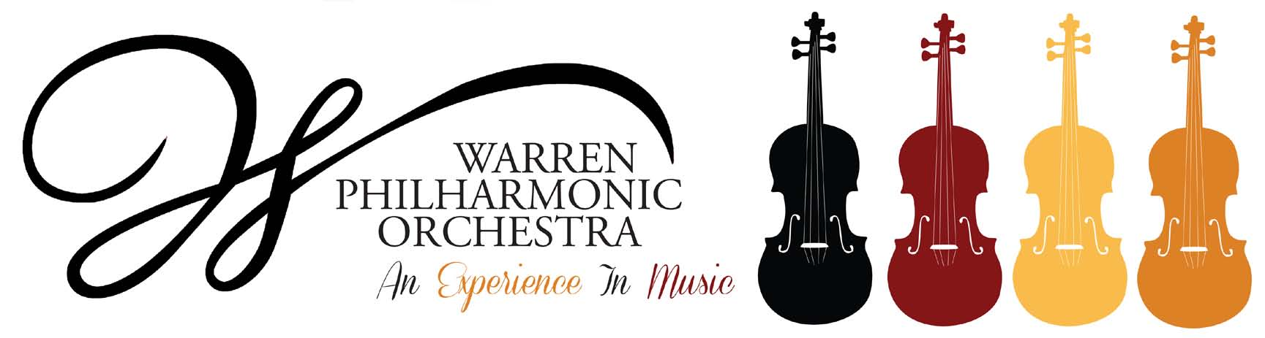

P.O. Box 8507 Warren, OH 44484-8507

**PRESS RELEASE** FOR MORE INFORMATION:

FOR IMMEDIATE USE Leanna Dunaway

Phone: 330-399-3606  
 Email: [warren.philharmonic@gmail.com](mailto:warren.philharmonic@gmail.com)

**Warren Philharmonic Orchestra Announces Season Subscription Campaign**

The Warren Philharmonic Orchestra's 56th season subscription campaign is now under way. The 2022-2023 season features two public concerts on Sunday, October 23, 2022, and April 23, 2023, at First Presbyterian Church, 256 Mahoning Avenue, NW, Warren. Concerts begin at 3 p.m. under the direction of the renowned conductor Susan Davenny Wyner. Season subscribers receive a ticket to each of our two concerts as well as one free ticket to bring a friend to either concert. And our flex plan allows the use of any ticket for either concert this season. Subscribers get three tickets for the price of two! Single performance tickets are available at the door. Children 12 and under are admitted free, when accompanied by an adult.

The October 23 program – ***Luminous and Dancing Spirits!*** – features music by a gifted sister, rarely heard, and her famous brother, along with striking dances from different cultures. Included are an *Overture* by Fanny Mendelssohn Hensel, *Greek Dances* by Nikos Skalkottas, *Starodávný Slavonic Dance* by Antonín Dvořák, *Hoedown* by Aaron Copland, the *Ritual Fire Dance* by Manual De Falla and the *Italian Symphony* by Felix Mendelssohn.​The concert is dedicated to the memory of Patricia Lynn Latham, a long-time supporter of our community’s arts and culture.

The April 23, 2023, performance evokes a ***Spring Celebration!*** with Beethoven's jubilant symphony, an elegant Fauré, and vibrant music by two dynamic American women. The orchestra will perform *Fanfare of Hope and Solidarity* written in 2020 by Augusta Read Thomas, *A Study for Orchestra* by Julia Perry, the *Pelléas et Mélisande Suite* by Gabriel Fauré, and Ludwig van Beethoven’s *Eighth Symphony*.​

"Our programs this season highlight the incredible variety and vibrancy of orchestral music and the skills of our musicians. They interweave some favorites with some surprises,” explains Davenny Wyner.

“The fall concert gives us an unusual opportunity to hear an amazing brother and sister from the 1800s. Fanny Mendelssohn Hensel, whose inspired and brilliant *Overture* begins the program, will join her brother Felix Mendelssohn, whose popular *Italian Symphony* ends the program. In between we are treated to Greek Folk dances, a Spanish Ritual Fire Dance, an American Hoe Down and a soulful and moving Ukrainian Dumka.

“In the spring, we celebrate two American women – Augusta Read Thomas and Julia Perry – whose works combine brilliant musical finesse and orchestral colorations. Thomas, a force of nature, is writing for major orchestras all over the world. Perry (1924-79), who spent much of her life in Akron, Ohio, was a prolific composer who won prizes and recognition here and abroad, even when her African American heritage put her at a great disadvantage. In 1965 the brilliant piece we perform was only the third work written by a woman to be played by the New York Philharmonic and the first ever by a woman of color,” Davenny Wyner continues.

“Our April concert also invites us to enjoy the debonair elegance of Fauré with his incidental music for Maeterlinck’s play *Pélleas et Mélisande*, and we finish with the rollicking high spirits of Beethoven's *Eighth Symphony*, of which he was justly proud!"

The Warren Philharmonic Orchestra is composed of 50 of the area’s finest professional musicians. In addition to its concerts for the public, the orchestra has performed free school concerts for thousands of area school children. The *Frank R. Bodor Strings of Joy* program provides free violin lessons to selected students in grades three through seven from Trumbull County schools.

More information about 2022-2023 season subscriptions and a form to order tickets can be obtained on the orchestra website, <http://www.warrenphilharmonic.org/>. Or, phone the orchestra office at 330-399-3606 to receive a printed copy of the season brochure.

“The orchestra family greatly appreciates our season ticket subscribers, patrons, and major gift donors who support our efforts to bring high quality musical experiences to our community,” said William Mullane, president of the orchestra’s board of trustees. “We are especially thankful for the support we receive that encourages our students to perform and witness great music close to home.”

For more information, contact the Philharmonic office at 330-399-3606 or email [warren.philharmonic@gmail.com](mailto:warren.philharmonic@gmail.com). Facebook: Warren Philharmonic Orchestra. Website: <http://www.warrenphilharmonic.org/>

# # #