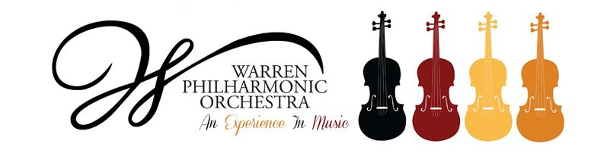

**Strings of Joy**

**Application**

Complete this form for each student in grades three through seven making application for free violin lessons beginning September 18, 2022. Please print.

|  |  |  |  |  |
| --- | --- | --- | --- | --- |
| Student’s name | | | | |
| Address |  | | | |
|  | | | |
| Phone(s) | | | | |
| Email | | | | |
| Parent/Guardian Name(s) | | | | |
| Name and Address of Parent/Guardian | |  | | |
|  | | |
|  | | |
| School Now Attending | | | | |
| Grade | | | | |
| Musical background | |  | | |
|  | | |
|  | | |
| Instrument(s) Student Plays | |  |  | |
|  |  | |
|  |  | |
| To what extent does the student read music? (Check one) | | | | ❒ Not at all |
| ❒ Beginner |
| ❒ Advanced |

Please attach a letter of recommendation and return this application by **September 1, 2022**.

If selected for Strings of Joy, the student and his/her parent or guardian must complete an *Enrollment Agreement* available at

<http://www.warrenphilharmonic.org/strings-of-joy-2022-2023.html>