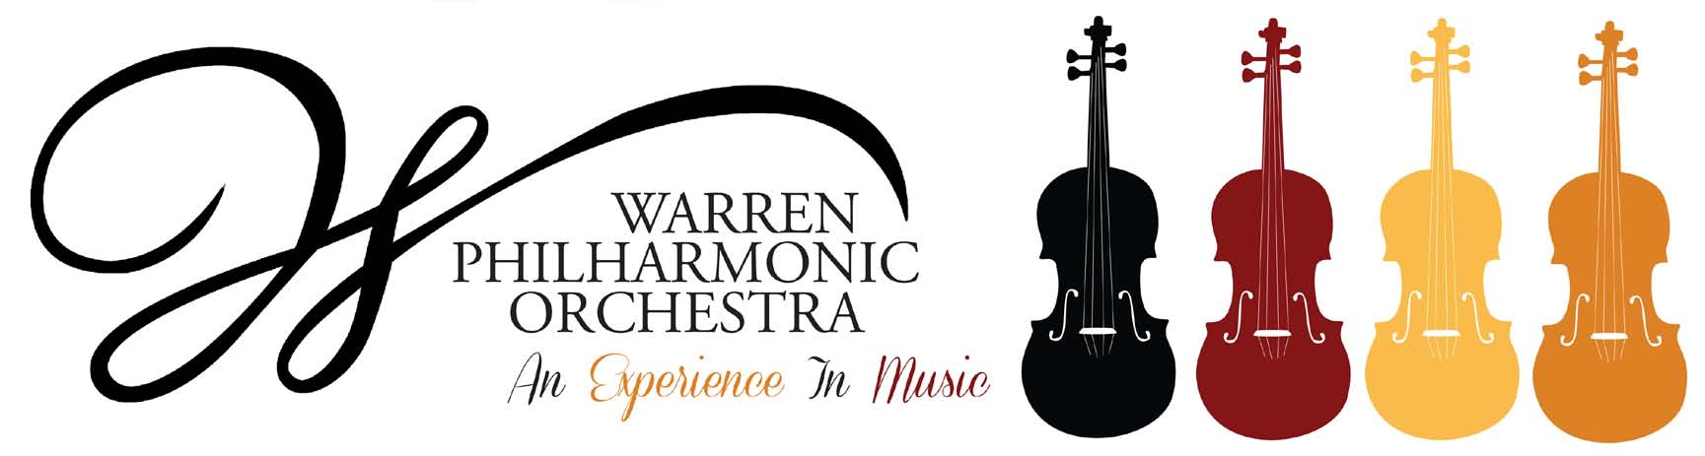P.O. Box 8507 Warren, OH 44484-8507

PRESS RELEASE FOR MORE INFORMATION:
FOR IMMEDIATE USE Leanna Dunaway
September 15, 2021 Phone: 330-399-3606 Email: warren.philharmonic@gmail.com

Spanish Journeys, the Colorful Music of Spain!
Next WPO Concert Announced

​No passport is required for Warren Philharmonic Orchestra’s fall concert featuring Spanish Journeys, the Colorful Music of Spain! The concert promises audiences heartful, passionate, vibrant, radiant performances, with a Grammy Award-winning soloist whose guitar evokes lively spirits from Spanish gardens. The concert begins at 3 p.m. on October 24, 2021, at First Presbyterian Church, 256 Mahoning Avenue, NW, Downtown Warren.

Under the direction of guest conductor Michael Gelfand, the orchestra will perform ​Intermezzo ​from La Boda de Luis Alonso by Gerónimo Giménez; Concierto de Aranjuez for guitar and orchestra by Joaquín Rodrigo, with guest soloist Jason Vieaux, recipient of the Grammy Award; Intermezzo from Goyescas by Enrique Granados; and Capriccio Espagnol by Nicolai Rimsky-Korsakov. Program notes are posted on the WPO website.

Maestro Gelfand notes that “The Giménez is an amazing and exciting pot boiler opener for the concert in heavy Spanish idiom. The audience will immediately be transported to Spain! The Concierto de Aranjuez is a great masterpiece, and Jason Vieaux will be outstanding. The Goyescas is an incredibly heartfelt and passionate change of pace piece from the others. Rounding out the program is the vibrant and radiant Capriccio Espagnol, a virtuoso work featuring each section of the orchestra. It is a very famous Spanish sounding composition by the famous Russian composer, Rimsky-Korsakov!”

NPR describes Jason Vieaux as “perhaps the most precise and soulful classical guitarist of his generation,” and Gramophone lists him “among the elite of today’s classical guitarists.” He has performed as soloist with over 100 orchestras, including Cleveland, Toronto, Houston, Nashville, and Orchestra of St. Luke’s, according to his website. Vieaux has taught at the Cleveland Institute of Music for 25 years.

Michael Gelfand has been principal cellist for the Warren Philharmonic Orchestra since 1975 and has been the Music Director/Conductor of the Greenville Symphony Orchestra (Pennsylvania) since 2002, conducting many concerts of orchestra, chamber orchestra, concerti, choral works, young audience concerts, and pops concerts. Gelfand was Professor of Music at the Dana School of Music at Youngstown State University from 1975 to 2014, and from 1980 to 1990 was Director of Orchestra and Chamber Orchestra, Opera and Musical Theater. He received YSU's Distinguished Professor Award, and was named Professor Emeritus.

Tickets for the October concert can be purchased at the door; adults $25, students $15. Children under the age of 13 are admitted free, with parent or guardian. The Orchestra will follow CDC COVID-19 guidelines in effect at the concert’s date. For more information about the concerts or any of our youth outreach programs, contact the Philharmonic office at 330-399-3606 or email warren.philharmonic@gmail.com. Facebook: Warren Philharmonic Orchestra. Website: http://www.warrenphilharmonic.org/

# # #

