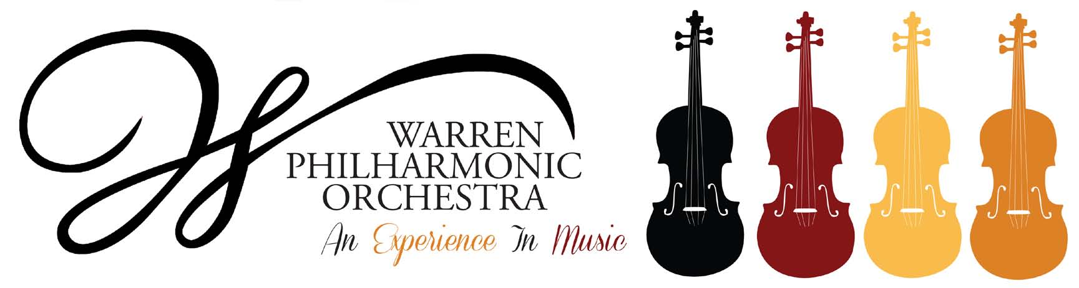
P.O. Box 8507 Warren, OH 44484-8507

PRESS RELEASE FOR MORE INFORMATION:
FOR IMMEDIATE USE Leanna Dunaway
Phone: 330-399-3606 Email: warren.philharmonic@gmail.com

Colorful Journeys!
Warren Philharmonic Concert – October 22, 2023 at 3:00 PM
First Presbyterian Church, 256 Mahoning Avenue, NW, Warren 44483

The Warren Philharmonic Orchestra’s razzle-dazzle Fall concert features a beloved symphony by Schubert, two contrasting American works whose composers will be present, a wild Czech dance, and picturesque evocations of Spanish dancers, mountain landscapes, marching Dragoons, and Toreadors from Bizet's Carmen. The concert begins at 3pm on October 22, 2023, at First Presbyterian Church, 256 Mahoning Avenue, NW, Downtown Warren.
Under the baton of music director and conductor Susan Davenny Wyner, the orchestra will perform Dance of the Comedians by Bedrich Smetana, Symphony No.8 'The Unfinished' by Franz Schubert, Sizzle (2000) by Margaret Brouwer, Epilogue (1996) by Yehudi Wyner and Carmen Suite No.1 by Georges Bizet. Program notes are posted on the WPO website.
"I am particularly excited by the contrasts and variety of experiences in this concert," explains Susan Davenny Wyner. "We go from the extroverted dazzle of dancing comedians and Brouwer's Sizzle (which drew its inspiration from overhearing rap coming from a car stopped at a traffic light!) to the depths and warmth of Schubert's 'Unfinished' Symphony and Yehudi Wyner's Epilogue. Bizet's famous Suite from Carmen --which takes us from exotic drama, to dreamy, to a celebratory parade -- will finish our adventure. It is hard to believe that Bizet died thinking that his opera Carmen was a failure!"
"To add to the excitement," Davenny Wyner continues, "both of our prize-winning American composers will be at the concert to introduce their pieces! They are not only important American figures--Wyner is a Pulitzer Prize and Grammy Award winner-- but they speak about their music in a way that is articulate, thoughtful, inspiring, and intriguing."
She adds: "Each piece in our program also highlights the individual 'characteristics' of our instruments: trumpets, trombones and horns; flutes, oboes, clarinets, bassoons; harp and a whole slew of percussion instruments. And, of course," she concludes, "it is the warmth, color, and glow of the stringed Instruments which make up what is so special about the orchestra's sound."
The Warren Philharmonic’s 45-plus professional musicians with 50 different instruments have won raves for their superb performances, stellar musicianship and captivating programs of compositions from the 1700s to pieces just composed. The October Fall concert opens the Orchestra’s 58th performance season.
Tickets for the October 22, 2023, concert can be purchased at the door: adults $30.00, students $15.00. Children under the age of 13 are admitted free, with a parent or guardian. Phone the Warren Philharmonic Orchestra office at 330-399-3606 or send email to warren.philharmonic@gmail.com for more information. Facebook: Warren Philharmonic Orchestra. Website: http://www.warrenphilharmonic.org/

