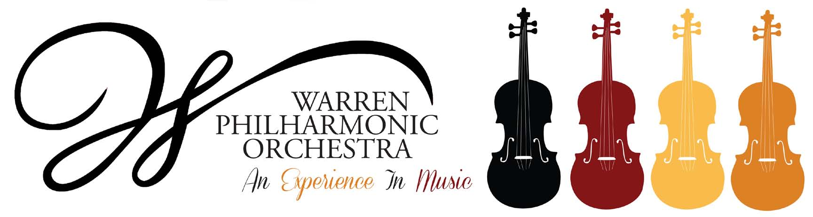
P.O. Box 8507 Warren, OH 44484-8507

PRESS RELEASE FOR MORE INFORMATION:
FOR IMMEDIATE USE Leanna Dunaway
Phone: 330-399-3606 Email: warren.philharmonic@gmail.com
The Sound of Magic!
Warren Philharmonic Concert – April 21, 2024, at 3:00 PM
First Presbyterian Church, 256 Mahoning Avenue, NW, Warren 44483

The Warren Philharmonic Orchestra Spring concert begins at 3pm on April 21, 2024, at First Presbyterian Church, 256 Mahoning Avenue, NW, Downtown Warren.
Under the baton of music director and conductor Susan Davenny Wyner, the orchestra will perform Symphony No. 35 in D major, KV. 385 - The 'Haffner' (1783) by Wolfgang Amadeus Mozart (1756-1791), Dances in the Canebrakes by Florence Price (1887-1953), and Symphony No. 7 in A Major, Op.93 by Ludwig van Beethoven. Program notes are posted on the WPO website.
"What particularly excites me about our 'Sound of Magic' concert," Susan Davenny Wyner says, "is the range of adventures it takes us on. Beginning and ending with towering masterpieces by Mozart and Beethoven, the program embraces a delicious American 'surprise!' in the middle. That's one of music's magics for me--that in the blink of an eye we can be transported into completely different worlds, soundscapes, and imaginative universes."
"Our unexpected surprise," she explains, "is by African American composer Florence Price (1887-1953), a prolific composer who was the first African American ever to have a symphony performed by a major Symphony orchestra. Her 'Dances in the Canebrakes,' which few people know, is a jazzy set of dances inspired by the rhythms and melodies of African and Caribbean music. The three dances take us from nimble rag-time moves to the seductive drag of a Caribbean "tango" and finish with a jaunty "Cake-walk" with its habanera-like swing."
"Our concert opens with Mozart's irresistible Haffner Symphony," she continues. "Fiery and bold, it starts with a brilliant fanfare that propels us into witty, character filled, sometimes gentle, often surprising adventures. It is Mozart at his best. Even he was proud of it. Composing it in white heat while in the midst of other projects (including marriage to his beloved Costanza!), he sent the music off to his father and promptly forgot about it. When he saw it again months later, he wrote to his father-- 'my new symphony positively amazes me!'"
"For the grand finale, I wanted to celebrate our gifted musicians and the marvelous 24 years I've had as Music Director and Conductor," Davenny Wyner enthuses. "Beethoven's great 7th Symphony, written some thirty years after the Mozart, takes us through extraordinary worlds--moving from deep mystery, the depths of despair, into rollicking fun and finally wild almost bacchanalian joy."
"I've often thought what fun it would be to travel back in time for those first performances!" she adds. "We have letters and newspaper accounts which range from amazement and delight —the second movement always had to be repeated—to thinking that Beethoven had gone completely mad! We even have a description of Beethoven conducting that first performance himself. He was already becoming deaf by that time and an eyewitness describes Beethoven crouching lower and lower as the music got soft and then rising to his full height only as the music grew loud. At the loudest spots he would add his shouts to the players' efforts. (No matter how exciting things become Sunday afternoon I promise not to do that.)"
"Since those first performances," she concludes, "many great writers and composers have tried to describe the power of this piece. Wagner described it this way: 'All impetuosity, all longing and raging of the heart here become the blissful exuberance of joy…This symphony is the very apotheosis of the dance.'"
The Warren Philharmonic’s 45-plus professional musicians with 50 different instruments have won raves for their superb performances, stellar musicianship and captivating programs of compositions from the 1700s to pieces just composed. The April Spring concert closes the Orchestra’s 58th performance season.
Tickets for the April 21, 2024, concert can be purchased at the door: adults $30.00, students $15.00. Children under the age of 13 are admitted free, with a parent or guardian. Phone the Warren Philharmonic Orchestra office at 330-399-3606 or send email to warren.philharmonic@gmail.com for more information. Facebook: Warren Philharmonic Orchestra. Website: http://www.warren-philharmonic.org/

