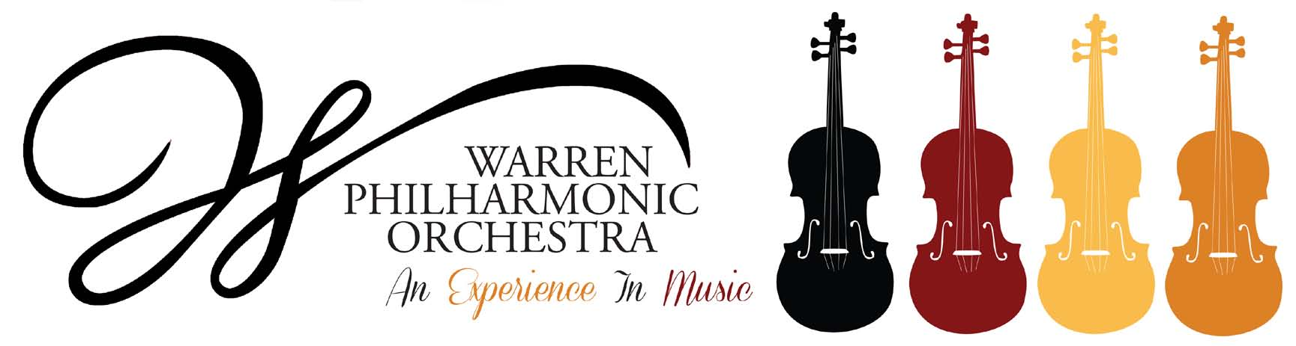

P.O. Box 8507 Warren, OH 44484-8507

**PRESS RELEASE FOR MORE INFORMATION:**

FOR IMMEDIATE USE Leanna Dunaway

Revised October 11, 2018 Phone: 330-399-3606 Email: [warren.philharmonic@gmail.com](mailto:warren.philharmonic@gmail.com)

***Secrets and Treasures!* – Next WPO Concert Highlights October Activities**

The Warren Philharmonic Orchestra’s fall concert – *Secrets and Treasures!* – features tricks and treats, as well as surprises and disguises from several well-known composers. The concert begins at 3 p.m. on October 28, 2018, at Christ Episcopal Church, 2627 Atlantic Street, NE, Warren. The orchestra will perform *Entrance of the Queen of Sheba* by George Frideric Handel, *Symphony No. 2, (The Bear)* by Joseph Haydn, *Creatures of Prometheus Overture* by Ludwig van Beethoven, *Overture to Cinderella* by Gioachino Antonio Rossini, *Chrysanthemums* by Giacomo Puccini, *The Count's Aria* from *The Marriage of Figaro* by Wolfgang Amadeus Mozart, and *Eri tu* from *Un Ballo in Maschera* byGiuseppe *​*Verdi.

Warren native Brian Keith Johnson will join the Orchestra as guest baritone soloist. Johnson is acclaimed for his many roles in opera and musical theater and is a favorite of Orchestra audiences.

The Warren Philharmonic Orchestra continues its outreach to area third through eighth grade students by sponsoring an instructional concert for students at Packard Music Hall in Warren on October 26, 2018, at 10 a.m. This live performance encourages students to discover the thrill of classical music and the instruments, performers and composers that enrich our lives. The concert is free to students from Trumbull-area schools. Reservation details have been sent to building principals. The orchestra will perform excerpts from the fall public concert. Instructional materials are available on the WPO website under the *2018-2019 Season* tab. The City of Warren Community Development Block Grant, Ohio Arts Council and the Youngstown Warren Regional Chamber of Commerce Foundation provided financial support for this event.

Applications are now being taken for the Orchestra's *Strings of Joy* program, that provides free violin lessons to selected Trumbull County students in grades three through seven. The next class will begin their lessons in January 2019. In addition to the free weekly lessons, the Orchestra loans each student an age-appropriate violin and provides printed music at no cost. Instructors are qualified musicians who are paid under a separate fund consisting of grants from the Youngstown/Warren Regional Chamber Foundation, other community organizations and individual donations. Details and application forms are available on the WPO website under the *2018-2019 Season* tab. Applications for this class are due by December 3, 2018.

The Orchestra’s *Art in Music Contest* will be held prior to the April 2019 public concert.

Tickets for the October concert can be purchased at the door; adults $25, students $15. Children under the age of 13 are admitted free, with parent or guardian. A season subscription campaign for both 2018-2019 concerts is now underway. For more information about the concerts or any of our youth outreach programs, contact the Philharmonic office at 330-399-3606 or email [warren.philharmonic@gmail.com](mailto:warren.philharmonic@gmail.com). Facebook: Warren Philharmonic Orchestra. Website: <http://www.warrenphilharmonic.org/>

# # #